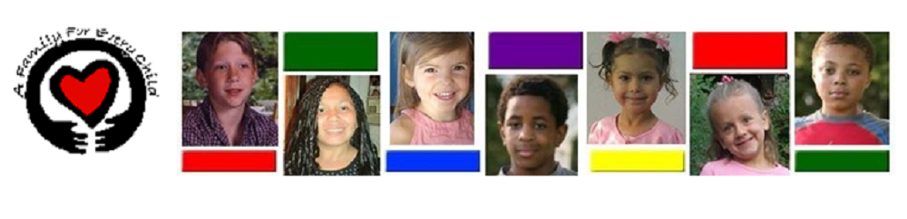To Whom It May Concern:

Ian Bogley volunteered with *A Family For Every Child* from July 2020 to the end of January2021. During his tenure us, Ian was a valued member of our Child Recruitment Team. In his position, Ian led a project to improve our Virtual Matching Event webinars. This project included mapping, organizing, and updating auto generated email templates, compiling data for our Virtual Child and Family Matching Events, organizing information, and proposing changes to the system.

In analyzing the needs of the project, Ian had to become well versed in our Salesforce customer relationship manager, learning not only the system by which we schedule events and their participants, but also the process to manage workflows, email templates and our current data collection process. Ian also gained skills with the Constant Contact email marketing service and the use of surveys and promotional emails created within the service.

I found Ian to be punctual, hard-working, conscientious, and showing great initiative. He arrived at the office ready to work without specific instruction and transitioned to a virtual format with ease. I found him to have strong attention to detail, critical thinking, and problem-solving skills. Ian rose to the challenge of not only learning a rather unorganized and unorthodox system, but also in decerning areas in need of improvement. His efforts have led us to the next step of development to not only streamline processes, but to improve data collection for one of our most successful and popular recruitment tools. These recruitment tools benefit not only foster children awaiting adoption, but families seeking to adopt from foster care as well.

I have been extremely happy with Ian’s work; he is welcome to return to volunteer service with us, should he choose to do so. If you have additional questions regarding Ian’s term with *A Family For Every Child*, I encourage you to email or call and I will be happy to assist you further.

Sincerely,

*Kelli Smith*

Child and Family Operations Coordinator

Volunteer Coordinator

A Family For Every Child

1675 W. 11th Avenue

Eugene, Oregon

kelli.smith@afamilyforeverychild.org

541-343-2856